2016届八年级下期期末模拟检测试卷
Name:_____________________ No. _______________________ Score________________
A 卷（共100分）
第一部分 听力部分 （共25小题，计25分）
一、听句子，根据所听到的内容选择正确答语。每小题念两遍。（共6小题，每小题1分；计6分）
( )1. A. Yes, please. B. No, I’m busy. C. Sorry, I am new here．
( )2. A. For two years. B. For five kilometers. C. For another ten minutes.
( )3. A. It’s in Brazil. B. The Caspian Sea. C. The Yangtze River.
( )4. A. Yes, I did. B. Yes, it is. C. Yes, I have.
( )5. A. I studied for the test. B.I am cooking. C. I was listening to English.
( )6. A. It’s a fairy tale. B. It’s written by a German. C. It’s really fun.
- 听句子，选择与所听句子内容相符的图片，并将代表图片的字母填在答题卡的相应位置。每小题念两遍。（共4小题，每小题1分；计4分）
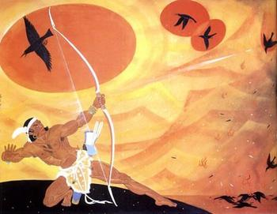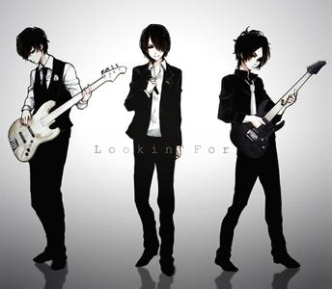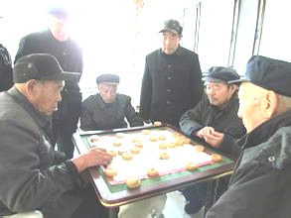
A B C D
7. ___________ 8. __________ 9. ___________ 10. _____________
- 听对话，根据对话内容及问题选择正确答案。每小题念两遍。（共10小题，每小题0.5分；计10分）
( )11. A. A farmer. B. A doctor. C. A teacher.
( )12. A. 5 years. B. 15 years. C. 50 years.
( )13. A. Because he likes the character Peter Pan. B. Because it’s a classical.
C. Because he doesn’t like going to school.
( )14. A. In the school . B. Near the supermarket. C. In the supermarket.
( ) 15.A. Tim. B. Tony. C. Susan.
( )16. A. Tomorrow. B. The day before yesterday. C. The day after tomorrow.
( )17. A. Once B. Twice. C. Three times.
( )18. A. Join the club. B. Clean the pay phones. C. Do anything he likes.
( )19. A. He doesn’t seem to welcome the changes. B. He thinks it’s great.
C. He thinks they bring beautiful memories.
( )20. A. She was making a phone call. B. She was watching a film.
C. She was playing tennis.
四、听短文，根据短文内容选择正确答案。短文念三遍。（共5小题，每小题1分；计5分）
( )21. Mary and John worked ____________.
A. in an army. B. in a factory C. in a hospital
( )22. This story happened _______________.
A. during the World War I B. during the World War II. C. in the 1840s.
( )23. Mary communicated with John by ___________.
A. writing to each other. B. calling each other. C. chatting online.
( )24. Mary didn’t receive his letter because ___________.
A. he didn’t love her anymore. B. he was injured. C. he was busy.
( )25. From the story, we know Mary and the doctor were ___________.
A. friends. B. mother and daughter. C. strangers.
五、听短文，根据短文内容完成下面表格。短文念2遍（共5小题，每小题l分；计5分）

The couple | They 1. __________________________________ for 25 years.
The wife’s wish | She wants to 2. _____________ around the world.
The husband’s wish | He wants to have a woman 3. __________________ than him.
The result | The wife gets the 4. ____________ in her hand and the husband becomes 5.______________ years old.

第二部分 基础知识运用 （共45小题，计45分）
- 选择填空（共25小题，每小题1分；计25分）
- 从以下4个小题中，选出与各句中画线部分意思相同或相近、并能替换画线部分的选项。（共4小题，每小题1分；计4分）
A. search for B. right now C. just now D. continued
( )26. Our teacher is explaining the difficult math problem at the moment.
( )27. Ann went on reading her book when I spoke to her.
( )28. A moment ago, my friend called me to ask how it was going with me.
( )29. Recently, many teenagers give up study to look for jobs in modern cities..
B.从以下各题的A、B、C三个选项中选择正确答案。（共17小题，每小题1分；计17分）
( ) 30. Mrs. White says ____ 8-year-old boy is _____ honest student because he never tells lies.
A. an, an B. an, the C. the, an
( ) 31. During the summer vacation, I usually go to the city library to _____ some books.
A. take B. lend C. borrow
( ) 32. Last weekend, Nancy made some cookies _____ for some money to help the students
in the rural area.
A. sell B. to sell C. sold
( ) 33. Doctors suggest that we shouldn’t read _____ the sunlight, because it’s bad for our eyes.
A. under B. in C. on
( ) 34. ---What do you think of watching TV?
---One point is certain. Television in is neither good nor bad.
A. itself B. themselves C. himself
( ) 35. ---I feel so tired these days. When can we have a rest?
---If it ______ fine tomorrow, we ______ boating. I hope you can relax yourself.
A. does, go B. will be, will go C. is, will go
( ) 36. ---Why don’t we go home by air, Mom? It’s much faster.
---We shouldn’t spend the money we ______ for the homeless people.
A. had B. run out of C. raised
( ) 37. ---I missed the football match last night.
---_______
A. So I did. B. What a pity! C. Neither did I.
( ) 38. ---Is that your teacher?
---That can’t be Mr. Wang. He ______ England with his wife.
A. has gone to B. has been to C. is going to
( ) 39. ---That old man has two kids.
---Yeah. They are studying abroad, so ______ of them can care for him.
A. either B. both C. neither
( ) 40. ---Hey, Jack, why did you make so many mistakes in the test?
--Sorry, Michael. I _______ when you checked the answers. I stayed up late watching the football games last night.
A. fell asleep B. was sleeping C. was sleepless
( ) 41. William is a top student and he _______ the school physics club for 2 years.
A. has been a member of B. has joined C. has fallen in love with
( ) 42. ---What do you think of the Spanish Men’s football team?
---It can’t be ______. They lost the first two games.
A. better B. worse C. more popular
( ) 43. My grandfather took my broken bike to the shop and asked the worker there to ______.
A. hand it out B. fix it up C. put it off
( ) 44. Kate was so glad ________ she received a Christmas gift from his grandparents away in Thailand.
A. that B. when C. if
( ) 45. Ben thanked Ms. Lee for making _______ possible for him to have Lucky.
A. it B. this C. him
( ) 46. ---Which do you think is the ______ book in China?
---Journey to the West. It has excited thousands of millions of Chinese.
A. most boring B. most meaningless C. most interesting
C.补全对话。根据对话内容，从方框中选出适当的选项补全对话。（共4小题，每小题1分；计分4分）
Messi: Have you seen Jim these two days?
- What did he say in his letter?
- Thanks.
- Has he been there before?
- Have you heard from him?[来源:Zxxk.Com]
Tom: No, I haven’t. He’s gone to Japan to see his grandfather?
Messi: __47_________.
Tom: Of course! He lived there before he came to London.
Messi: _48__________.
Tom: Yes, I have just received a letter from him.
Messi: _49__________.
Tom: He said he had a good time there and would stay for another month. Then he was going to return to England. He also wanted me to give his best wishes to you.[来源:学.科.网]
Messi: Oh, well. __50_________.
- 完型填空。分别通读下面两篇短文，根据短文内容，从A、B、C 三个选项中选出可以填入空白处的最佳答案。（共20小题，每小题1分；计20分）
A
In front of my daughter Sindu, was a bowl filled with cabbage. She 51_____ cabbage. She
only sat there 52______ with tears in her eyes.
“Sindu, darling, why don’t you eat a little? Your mom will shout at me.”Sindu wiped (擦) her tears with the back of her hand.
“OK, Dad. I'll eat, just a little.”Then Sindu said, “Dad, if I eat it all, will you give me 53_____ I want?” “Yes, within reason.”
She began to eat 54_______. It took her half an hour to finish the food. Then she came up and said, “Dad, I want to have my head shaved!”
“Sindu, why don’t you ask for 55_______? If we see you with a clean-shaven head, we will be sad” I said.
“But, Dad, you promised! Now, you are going back on your words.”
I had to 56_______ my promise. Sindu had all her hair cut off. She looked beautiful.
On Monday morning, I took her to school. When we arrived, a boy got out of a car, 57_____,
“Sindu, please wait for me!” Guess what? The boy had no hair, either.
“Sir, your daughter is _58______!” a man got out of the car. “That boy is my son Harish. He
has cancer. He lost his hair when he got ill. Sindu 59_________so Harish felt less different. She’s a special girl.”
I stood 60________, “My little girl, you teach me how selfless (无私的) real love is!”
( )51. A. liked B. enjoyed C. hated
( )52. A. in the end B. all the time C. in silence
( )53. A. whoever B. whenever C. whatever
( )54. A. quickly B. slowly C. completely
( )55. A. everything else B. something else C. nothing else
( )56. A. keep B. break C. change
( )57. A. shouting B. reminding C. including
( )58. A. ugly B. beautiful C. great
( )59. A. cut off her B. cut hers off C. cut off hers
( )60. A. for a while B. in the afternoon C. for a day
B
The panda is one of the animals most in danger. There are about 1,000 pandas 61________in nature reserves（保护区） today. Zoos and research centers look after about 160 pandas. Scientists are studying 62_________ they live and more baby pandas are born in the zoos.
Pandas live in the forests and mountains of 63_________China. They mainly live on bamboo and each panda needs to eat a lot of bamboo every day. The area of bamboo is becoming 64______ for many different reasons. Pandas have less and less land to live on. Pandas don’t have many babies, and baby pandas often die. The situation is becoming very serious.
Our government is working hard to save pandas. There are 65_______thirty nature reserves to protect pandas but these are not enough .The government 66__________a new plan to help pandas in the past years. The nature reserves will be bigger and the 67__________will grow better. Then the pandas will have enough food to eat and enough places to live. Pandas born in the zoos may go back to live in the nature reserves.
Most people love pandas. The panda is one of the best-known animals in the world. It is the symbol for the World Wide Fund for Nature. The WWF works to protect all animals 68_______, so the panda has become the symbol of all animals in danger. There is 69_________a long way to go to save the panda. Think of other animals in danger 70_________tigers, whales, turtles and elephants-we need to save the panda, and we need to save them, too.
( )61. A. live B. living C. lived
( )62. A. where B. what C. how
( )63. A. Southwestern. B. Southeastern C. West
( )64. A. smaller B. fewer C. more
( )65 A. on B. over C. under
( )66. A. made B. is making C. has made
( )67. A. bamboo B. temperature C. price
( )68. A. in need B. in danger C. in the control
( )69. A. still B. already C. just
( )70. A. thanks to B. for example C. such as
第三部分 阅读理解 （共15小题，计30分）
- 阅读下面短文，根据短文内容判断句子的正误。正确的涂“A”，错误的涂“B”。 （共5小题，每小题2分；计10分）
Mr. Howe worked in an office. He studied the old things and sometimes bought some for himself. So he got a lot of money. Eight years ago, when he was sixty-five, he retired（退休）. He needn't worry about food or clothes. He was busy before, but now he has enough time to rest. He loves playing Ping-Pong and spends most of his time on the game. He had never been ill until he had got a headache one day. He was taken to a hospital at once. The doctors looked him over carefully and did their best to save him but he felt worse and worse. He made his son send for a witch（巫婆）.
“Do the people in heaven play Ping-Pong, madam?” asked Mr. Howe. “I'm sorry I don't know, sir.” answered the witch. “Let me go and ask about it for you.” That evening the witch came and said, “I've just been to heaven, Mr. Howe. I've brought two pieces of news to you. One is good and the other is bad.”
“Tell me the good news first, please.” Mr. Howe said.
“Most of the people in heaven(天堂) play Ping-Pong,” said the witch. “But you'll have a game there the day after tomorrow!”
( ) 71. Mr. Howe is seventy-three now.
( ) 72. Mr. Howe has little money, so he is poor.
( ) 73. As he rested very well all the time, Mr. Howe has never been ill.
( ) 74. The doctors didn't do their best to save Mr. Howe, so he felt worse and worse.
( ) 75. The bad news meant Mr. Howe would die in two days.
九、 阅读下面A、B两篇短文，根据短文内容选择正确答案。（共10小题，每小题2分；计20分）
A
As we know, Chengdu has changed a lot. Most of the people feel much safer now. More and more trees are being planted in the city. And every day you can see many old people play sports everywhere. The change makes the people in the city live a happy life. The small survey below is from the people who live in Chengdu. One hundred persons were chosen to answer the questions last week.
What they want | Health [来源:Z*xx*k.Com] | Safety | Food[来源:学科网ZXXK][来源:学|科|网Z|X|X|K]
What they want | 52% | 33% | 15%
Where they like to live | In a quieter place | In a busier place | In a greener place
Where they like to live | 15% | 5% | 80%
What they think of working in the city | Bad | Good | No idea
What they think of working in the city | 8% | 80% | 12%
Whether they plan to change their working places | Yes | No | Hard to say
Whether they plan to change their working places | 39% | 41% | 20%
( ) 76.____ persons were chosen to answer the questions last week.
A. 100 B.80 C.39
( )77.From the survey，____ of the people in Chengdu care about health.
- 41% B.39% C.52%
( ) 78.Most people think working in Chengdu is____.
- bad B. good C. hard
( )79.From the survey, we know most people want to live____.
A. in a busier place B. in a quieter place C. in a greener place
( )80.According to the passage and the survey, we know that____.
A. most people plan to change their living places
B. the people in Chengdu don't like planting trees
C. the change in Chengdu makes people enjoy living there
B
In 1975, Junko Tabei became the first woman to reach the top of Mount Everest in the Himalaya Mountains, the highest mountain in the world at 29,035 feet.
Junko was born in 1939 and grew up in a small town in Japan. During her childhood, she was thin and weak. At the age of 10, Junko went on a school trip. The students climbed two mountains, and Junko loved it.
She could climb in her own time and ability. After Junko graduated from university in 1962, she joined several climbing clubs. But they had mostly men members. Some refused to climb with a woman. In 1965, Junko married a well-known Japanese climber. Over the years, they climbed all the highest mountains of Japan.
Meanwhile Junko started a woman's climbing club. By 1972, she was chosen to lead a team of women to climb Mount Everest. It took three years for the 15 women to train and raise money for their climb.
Finally in 1975, the team went to climb the mountain. They found nine guides to help them climb up the mountain. Everything went well until the morning of May 4. Suddenly a huge amount of snow and ice fell on them. One guide saved Junko. She rushed to help others. Everyone was alive but they had injuries, including Junko. However, the team decided to continue their climb. About two weeks later, on May 16, Junko reached the top of Mount Everest. Later she said, “ can't understand why men make all this fuss (小题大做) about Everest-it's only a mountain.”
( ) 81. When Junko was 10, she_______.
A. didn't like sports or games B. often went on school trips
C. realized that she loved to climb
( ) 82. In 1972, Junko ______.
A. trained 15 women for their climb
B. raised enough money for a climb to Mount Everest
C. became a leader of a woman team to climb Mount Everest
( ) 83. During their climb to Mount Everest, Junko and her team________.
A. got little help from the guides
B. went on climbing after they had injuries
C. had to stop climbing because of their injuries
( ) 84. Which of the following is NOT RIGHT?
A. There were 15 members in the women climbing team.
B. In the beginning, Tabei was welcomed by the climbing clubs because of her abilities.
C. Tabei thought it was not difficult to climb the Everest.
( ) 85. What does the author mainly want to tell us?
A. Mountain climbing is dangerous.
B. Women can do the same things as men.
C. Junko was the greatest climber in the world.

期末模拟检测试卷A卷答案
1-5 CABCC 6-10 CCDAB
11-15 BBCCC 16-20 CABAC
21-25 ABABC 26-30 BDCAC
31-35 CBBAC 36-40 CBACB
41-45 ABBBA 46-50CCDAB
51-55CCCBB 56-60AACBA
61-65BCAAB 66-70 CABAC
71-75ABBBA 76-80ACBCC
81-85 CCBBB

听力
五、听短文，根据短文内容完成下面表格。
1. have been married
2. travel
3. 30 years younger
4. tickets
5. ninety(90)

附件1：律师事务所反盗版维权声明
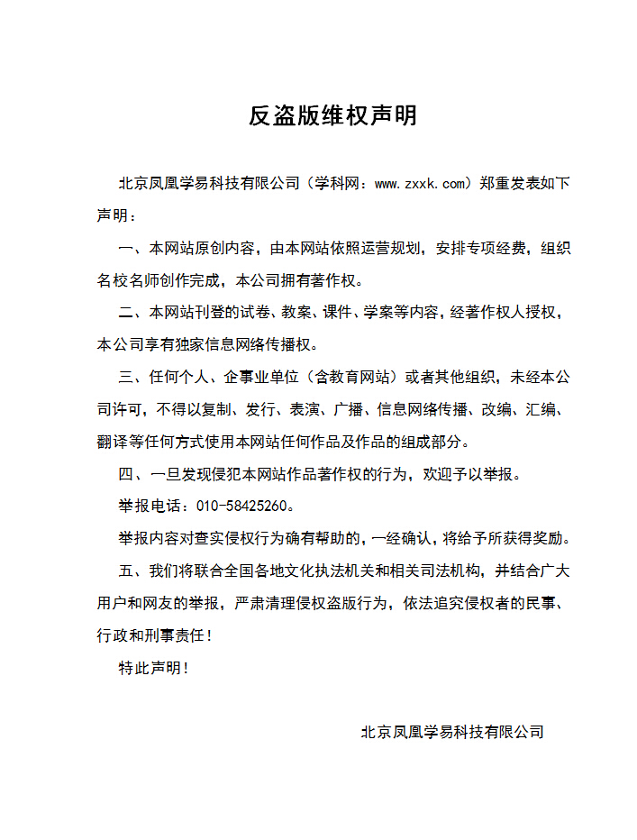
附件2：独家资源交换签约学校名录（放大查看）
学校名录参见：http://www.zxxk.com/wxt/list.aspx?ClassID=3060

